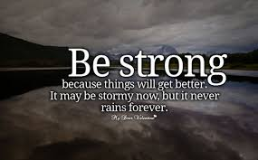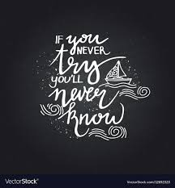

ROCK ALL YOUR FINALS!!!!!!!!!!!!!!

**Writing: Escritura~ Tienes que saber como… You need to know how to…**

1. Talk about your schedule, classes, teachers and which classes are your favorite
2. What are you like? Describe yourself, your family and your friends. What you all are like and are not like.
3. What do you like and not like to do.

**Escuchar: KNOW YOUR VOCABULARIO**

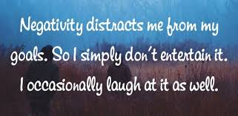**Especially from 2B and your food (3A y 3B)**